P 4 Manipulating Administrative Distances
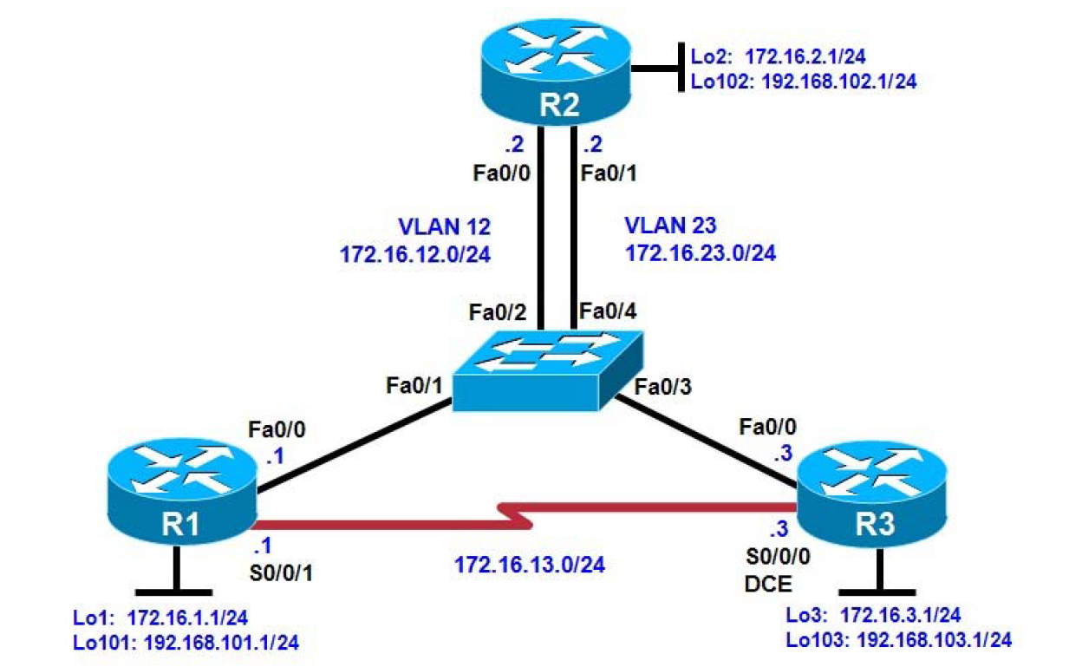

Background
In this lab, you will compare the RIP and OSPF routing protocols based on how efficient they are at selecting
routes, as well as what happens when you manipulate administrative distances in the routing table.
Note: This lab uses Cisco 1841 routers with Cisco IOS Release 12.4(24)T1 and the Advanced IP Services
image c1841-advipservicesk9-mz.124-24.T1.bin. The switch is a Cisco WS-C2960-24TT-L with the Cisco IOS
image c2960-lanbasek9-mz.122-46.SE.bin. You can use other routers (such as a 2801 or 2811), switches
(such as 2950), and Cisco IOS Software versions if they have comparable capabilities and features.
Depending on the router or switch model and Cisco IOS Software version, the commands available and output
produced might vary from what is shown in this lab.

Objectives
• Configure RIP on a router.
• Configure OSPF on a router.
• Manipulate administrative distances.
• Compare routing protocol behavior.

Step 1: Configure router loopbacks and addressing.

R1# conf t
R1(config)# interface loopback 1
R1(config-if)# ip address 172.16.1.1 255.255.255.0
R1(config-if)# interface loopback 101
R1(config-if)# ip address 192.168.101.1 255.255.255.0
R1(config-if)# interface fastethernet 0/0
R1(config-if)# ip address 172.16.12.1 255.255.255.0
R1(config-if)# no shutdown
R1(config-if)# interface serial 0/0/1
R1(config-if)# bandwidth 64
R1(config-if)# ip address 172.16.13.1 255.255.255.0
R1(config-if)# no shutdown

R2# conf t
R2(config)# interface loopback 2
R2(config-if)# ip address 172.16.2.1 255.255.255.0 R2(configif)#
interface loopback 102
R2(config-if)# ip address 192.168.102.1 255.255.255.0
R2(config-if)# interface fastethernet 0/0
R2(config-if)# ip address 172.16.12.2 255.255.255.0
R2(config-if)# no shutdown
R2(config-if)# interface fastethernet 0/1
R2(config-if)# ip address 172.16.23.2 255.255.255.0
R2(config-if)# no shutdown

R3# conf t
R3(config)# interface loopback 3
R3(config-if)# ip address 172.16.3.1 255.255.255.0
R3(config-if)# interface loopback 103
R3(config-if)# ip address 192.168.103.1 255.255.255.0
R3(config-if)# interface fastethernet 0/0
R3(config-if)# ip address 172.16.23.3 255.255.255.0
R3(config-if)# no shutdown
R3(config-if)# interface serial 0/0/0
R3(config-if)# bandwidth 64
R3(config-if)# ip address 172.16.13.3 255.255.255.0
R3(config-if)# clock rate 64000
R3(config-if)# no shutdown

Step 2: Configure switch VLANs.

Switch(config)# vlan 12
Switch(config-vlan)# name R1-R2
Switch(config-vlan)# vlan 23
Switch(config-vlan)# name R2-R3
Switch(config-vlan)# exit

Switch(config)# interface fastEthernet 0/1
Switch(config-if)# description To R1 Fa0/0
Switch(config-if)# switchport mode access
Switch(config-if)# switchport access vlan 12
Switch(config-if)# interface fastEthernet 0/2
Switch(configif)# description To R2 Fa0/0
Switch(config-if)# switchport mode access
Switch(config-if)# switchport access vlan 12

Switch(config-if)# interface fastEthernet 0/3
Switch(configif)# description To R3 Fa0/0
Switch(config-if)# switchport mode access
Switch(config-if)# switchport access vlan 23
Switch(config-if)# interface fastEthernet 0/4
Switch(configif)# description To R2 Fa0/1
Switch(config-if)# switchport mode access
Switch(config-if)# switchport access vlan 23

Step 3: Configure RIP.

R1(config)# router rip
R1(config-router)# version 2
R1(config-router)# no auto-summary
R1(config-router)# network 172.16.0.0
R1(config-router)# network 192.168.101.0

R2(config)# router rip
R2(config-router)# version 2
R2(config-router)# no auto-summary
R2(config-router)# network 172.16.0.0
R2(config-router)# network 192.168.102.0

R3(config)# router rip
R3(config-router)# version 2
R3(config-router)# no auto-summary
R3(config-router)# network 172.16.0.0
R3(config-router)# network 192.168.103.0

R1# show ip route rip
R2# show ip route rip
R3# show ip route rip

Step 4: Configure OSPF.

R1(config)# interface loopback 1
R1(config-if)# ip ospf network point-to-point
R1(config-if)# interface loopback 101
R1(config-if)# ip ospf network point-to-point
R1(config-if)# router ospf 1
R1(config-router)# network 172.16.0.0 0.0.255.255 area 0
R1(config-router)# network 192.168.101.0 0.0.0.255 area 0

R2(config)# interface loopback 2
R2(config-if)# ip ospf network point-to-point
R2(config-if)# interface loopback 102
R2(config-if)# ip ospf network point-to-point
R2(config-if)# router ospf 1
R2(config-router)# network 172.16.0.0 0.0.255.255 area 0
R2(config-router)# network 192.168.102.0 0.0.0.255 area 0

R3(config)# interface loopback 3
R3(config-if)# ip ospf network point-to-point
R3(config-if)# interface loopback 103
R3(config-if)# ip ospf network point-to-point
R3(config-if)# router ospf 1
R3(config-router)# network 172.16.0.0 0.0.255.255 area 0
R3(config-router)# network 192.168.103.0 0.0.0.255 area 0

R1# show ip ospf neighbor
R1# show ip route

R2# show ip ospf neighbor
R2# show ip route

R3# show ip ospf neighbor
R3# show ip route

Step 5: Modify the routing protocol distance.

R1(config)# router rip
R1(config-router)# distance 100

R2(config)# router rip
R2(config-router)# distance 100

R3(config)# router rip
R3(config-router)# distance 100

R1# show ip route
R2# show ip route
R3# show ip route

R1# show ip protocols

Step 6: Modify distance based on route source.

R1(config)# router ospf 1
R1(config-router)# distance 85 192.168.100.0 0.0.3.255

R2(config)# router ospf 1
R2(config-router)# distance 85 192.168.100.0 0.0.3.255

R3(config)# router ospf 1
R3(config-router)# distance 85 192.168.100.0 0.0.3.255

R1# show ip route
R2# show ip route
R3# show ip route

R1# show ip protocols

Step 7: Modify distance based on an access list.

R1(config)# access-list 1 permit 172.16.0.0 0.0.255.255
R1(config)# router rip
R1(config-router)# distance 65 0.0.0.0 255.255.255.255 1

R2(config)# access-list 1 permit 172.16.0.0 0.0.255.255
R2(config)# router rip
R2(config-router)# distance 65 0.0.0.0 255.255.255.255 1

R3(config)# access-list 1 permit 172.16.0.0 0.0.255.255
R3(config)# router rip
R3(config-router)# distance 65 0.0.0.0 255.255.255.255 1

R1# show ip protocols
R1# show ip route

R2# show ip protocols
R2# show ip route

R3# show ip protocols
R3# show ip route

